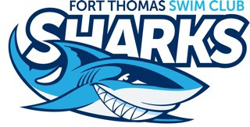
Fort Thomas Sharks Swim Team
2022 Parent Meet Guide

We’re so happy that you and your child are part of FTSC Swim Team, the Sharks! Here’s some information to make your swim season go smoothly. Don’t hesitate to ask the coaches or the swim team parent coordinators if you have any questions.

Team Goals for the Season:
- Have fun
- Swim fast
- Improve stroke technique
- Show team spirit and support each other

Our team is led this year by head coach Kevin Kampschmidt and assistant coaches Savannah Brady, Will Griffith and Jack Banks.

What you need to do before a meet:

- Declare your swimmer’s intention for attendance for each meet (in Team Unify, find the meets under Events). Coaches use this listing for their entries. If you do not sign in or out, your swimmer cannot be entered in the meet’s events. Declaration deadline for each week’s meet is MIDNIGHT on Tuesday.

- Sign up to volunteer during the meet. Parent volunteers are needed for all home meets, away meets, All Star Meet and Champ Meet. We ask that at least one adult from each family volunteer in some capacity at each meet. If you don’t know what’s going on, don’t worry. You can shadow an experienced volunteer.

- Remind your child of the week’s theme. The Sharks pride themselves on team spirit, and there’s a theme for each meet.
- 6/9 (Beechwood @ Ft Thomas): Hawaiian
- 6/16 (Bluegrass & Ft Thomas @ Taylor Mill): Pirates
- 6/23 (Ft Thomas @ Florence): Sports Team Spirit
- 6/30 (Five Seasons & Oakbrook @ Ft Thomas): Party in the USA
- 7/7 (Ft Thomas @ Newport): Christmas in July
- 7/14 (Ft Thomas @ Brookwood): Tie Dye
- 7/18 All Star Meet @ Ft Thomas: Shark Week
- 7/21 Champ Meet @ Oakbrook: Shark Week

- On the day of the meet, look for an email with a heat sheet. It’s a good idea to print this heat sheet, if possible. Identify the events your child has been entered in to swim. Use a highlighter or a pen to mark your child’s events. Write these events on your child’s arm with a permanent marker. This way your child knows their events and heats. For 8 & Under swimmers please write their name on their back so that “critter getters” can easily identify your child. And don’t worry, if you can’t read the heat sheet, experienced parents are happy to help!
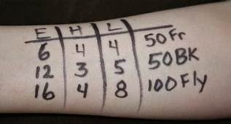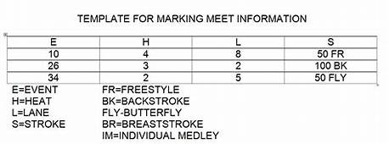
- Pack for the meet: It is helpful to label EVERYTHING with your swimmer’s name. Rolling coolers make great storage spots to keep items dry in the event of a rainy meet and can double as a place to sit.
- Team suit
- Goggles (2)
- Towels (2+)
- Water bottle
- Snacks
- Dry Clothes
- Cards/Games/Books
- Blanket
- Folding Chair
- Sharpie
- Heat Sheet
- Home meets: an item for the bake sale

What you need to do during a meet:
- Keep tabs on your kids. Parents are responsible for their children at all swim meets.
- Parents of younger children are expected to ensure their children get to the blocks or to the 8&U “critter getters” for their events. 8&U critter getters will assist swimmers in lining up behind the blocks but are not responsible for chasing down children for their events.
- Volunteer.
What to expect at a meet:
Warm ups for home swim meets begin at 5:15 p.m. and 5:45 for away meets. Swimmers should arrive at the pool 15 minutes before warm ups to find their designated area and set up. Swim meets begin at 6:30 p.m.
Swim Meet Order of Events for 8 & Under Swimmers:
(#13 & #14) 100 Medley Relay (Backstroke, Breaststroke, Butterfly, and Freestyle)
(#23 & #24) 25M Freestyle
(#33 & #34) 25M Breaststroke
(#47 & #48) 25M Backstroke
(#57 & #58) 25M Butterfly
(#75 & #76) 100M Freestyle Relay

8 & Under swimmers will be assisted to the blocks for their next event by 8 & under parent helpers called Critter Getters when the 13-14 age group is swimming the previous event. Please send your 8 & U child to the Critter Getter so they can organize them for the event. After the Butterfly event, there is a long break before the Freestyle Relay because 8 & unders do not compete in the Individual Medley (IM).
Order of Events for All Age Groups
Medley Relay
Freestyle
Breaststroke
Backstroke
VOLUNTEERS SHIFT: FIRST HALF VOLUNTEERS HAND OFF TO SECOND HALF
Butterfly
Individual Medley
Free Relay

The meet begins with events #11 & #12 Open 200 SC Meter Freestyle. Then every age group swims in the same order of events, beginning with 8 & Under Boys Medley Relay, then 8& U Girls Medley Relay, followed by 9-10 boys and girls, 11-12 boys and girls, 13-14 boys and girls and 15-18 boys and girls. When all of the medley relays are completed, the next event, Freestyle, begins with 8 & Under Boys.

In general, it takes about 20 minutes to complete each event for all age groups. As a result, the meet usually lasts about 2-3 hours, depending on the number of entries.
All swimmers need to stay back away from the starting blocks as they are waiting for their heats. It is also important for them to stay as quiet as possible so the swimmers ahead of them can hear the starter.

More information about volunteer roles, All Star Meet, Champ Meet and much more is available in the Team Handbook, which will be emailed to you and is also available on Team Unify under the Documents tab.

Let us know if you have questions. We’re looking forward to a great season.

Lesley-Ann Gracey (513-967-2449) and Karen Jones (859-653-6665)
Sharks Swim Team Parent Coordinators/Supporters

